**EXIT INTERVIEW**

Employee Name: Vijay Chauhan Supervisor: Neha Mam

Division: IT______________________________ Designation:Team Lead

Hire Date: 10-10-2022 __ Last Working Date: 11-01-2023 _________________

1. **Why are you leaving TECHVED?**

There is no reason .

**_________________________________________________**

1. **What did you like most about your job?**

Techved give me worked as Team lead . I was like it

**_______________________________________________________________________________________________________________________________________________________________________________________________________________________**

1. **What did you like least about your job?**
2. **VPN access and do Coding I like it.**
3. **Got more knowledge about Coding . like elf storage . I like this.**

**________________________________________________________________________**

**4. What did you think of your supervisor on the following points?**

**Almost Always Usually Sometimes Never**

Was consistently fair ( ) (√) ( ) ( )

Provided recognition ( ) (√ ) ( ) ( )

Resolved complaints (√) ( ) ( ) ( )

Was sensitive to employees' needs ( ) (√ ) ( ) ( )

Provided feedback on performance (√ ) ( ) ( ) ( )

Was receptive to open communication ( √) ( ) ( ) ( )

Followed TVD’s policies ( √) ( ) ( ) ( )

**5. How would you rate the following?**

**Excellent Good Fair Poor**

Cooperation within your team ( ) (√ ) ( ) ( )

Cooperation with other teams ( ) (√ ) ( ) ( )

Personal job training ( √) ( ) ( ) ( )

Equipment provided (materials, resources, facilities) (√) ( ) ( ) ( )

Company's performance review system (√) ( ) ( ) ( )

Company's new employee orientation program (√ ) ( ) ( ) ( )

Rate of pay for your job ( ) (√ ) ( ) ( )

Career development/Advancement opportunities (√ ) ( ) ( ) ( )

Physical working conditions ( ) ( √) ( ) ( )

Comments:

**6. Was the work you were doing approximately what you expected it would be?**

Yes No

Comments: Yes

**7. Was your workload usually:** Too heavy ( ) About right (√) Too light ( )

**8. Would you recommend the company to a friend as a good organization to work for?**

Most definitely (√) With reservations ( ) No ( )

**9. What suggestions do you have to make TECHVED a better place to work?**

TECHVED a better place to work. I can only say this.

**________________________________________________________________________________________________________________________________________________________________________________________________________**

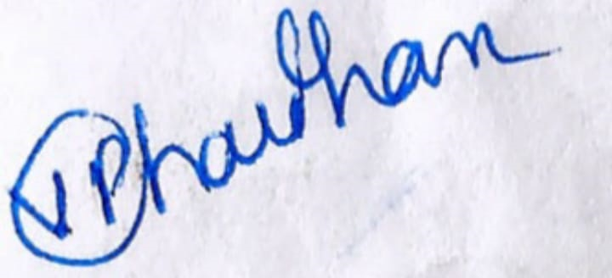

Human Resources Representative: Employee:

11-01-2023

Date: Date: